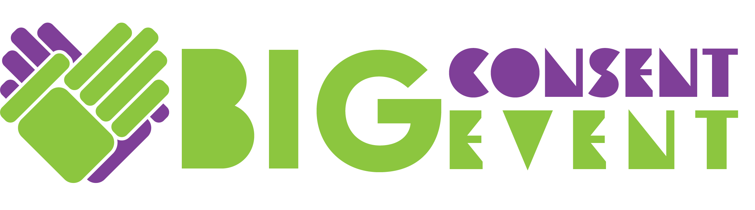
Friday 3/1/19
8:30 am – 2:30 pm

Agenda

8:30 – 9:00 Registration

9:00 – 9:25 Opening Ceremony and Introduction, with shared agreements

9:25 – 10:15 “Creating Consent Culture” presented by activists from Safe BAE

10:30 – 11:45 YOUTH WORKSHOPS:
- WORKSHOP A: Identifying and Communicating Consent (Safe BAE)
LOCATION: MAIN AUDITORIUM
- WORKSHOP B: Identifying and Communicating Consent (Safe BAE)
LOCATION: SYRE 108
- WORKSHOP C: Identifying and Communicating Consent (Teen Council)
LOCATION: LAIDLAW 216 A

- ADULT ADVISOR WORKSHOP: resources and materials to support conversations with students about consent and healthy relationships. LOCATION: SYRE 107

11:45pm – 12:30 Lunch and free time to visit interactive exhibits

12:30 – 1 pm Safe BAE Q and A

1:00 – 1:45 pm Team Time: Advisor Discussions (teams gather in small groups to process, reflect, and make plans for taking action)

2:45 – 2:30 pm Report out with action plans, final Send off, Evaluations

